Chapter 14, Problem 56.

(a) Show that for a bandpass filter,

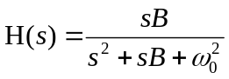

where B = bandwidth of the filter and ω₀ is the center frequency.

(b) Similarly, show that for a bandstop filter,

